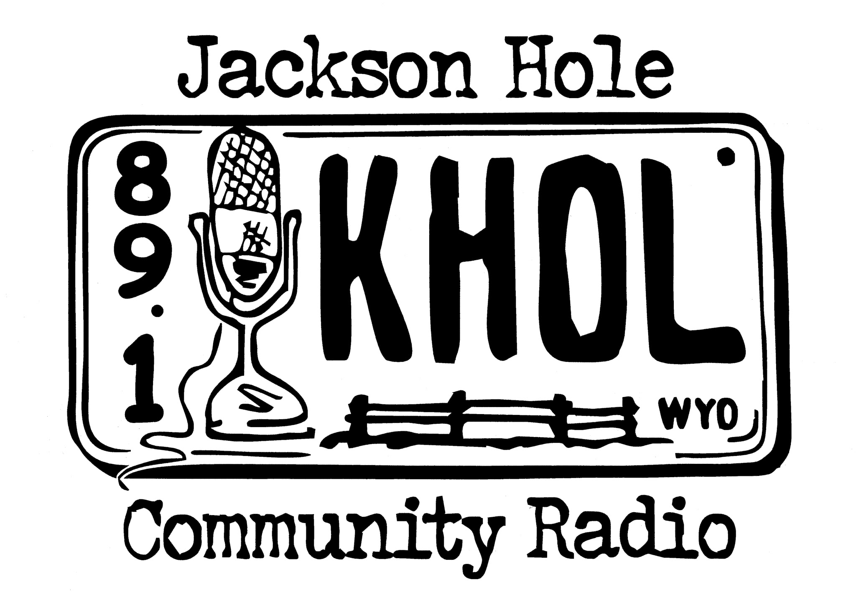
265 S. Cache St.
(in the Center for the Arts)
PO Box 588
Jackson, WY 83001 (307) 733-4030
info@jhcr.org

Music Programmer Application

Thank you for your interest in becoming a community programmer at 89.1 KHOL FM, Jackson Hole Community Radio. Before you become involved with KHOL, It is important to know and understand our mission.

KHOL’s mission is to provide news and information that is focused on the northwest region of Wyoming, to preserve our culture through locally produced programming, and to maintain the tradition of public radio by educating and informing listeners through a diversity of music and views that challenge people to explore new ideas.

KHOL strives to highlight content that receives little attention on current radio broadcasts. We wish to represent the community by directly engaging community participation– your participation.

Beyond providing commercial-free music to Jackson, KHOL offers a platform for community-oriented issues and information through our public affairs broadcasts. By providing access and the opportunity to produce local media, KHOL enhances our sense of community.

We would like to know about you, what genre of music/information your program will focus on, your schedule availability, and what experiences you’ve had that may be utilized to help KHOL in our many areas of need. Please complete the attached Programmer Application to help KHOL learn these topics.

Please submit the following materials together to Zach Zimmerman, Station Manager:
- Completed programmer application
- Membership dues
- Acknowledgement to comply with FCC rules and regulations
- Sample playlists

Thank you for taking the initiative to become a part of 89.1 KHOL FM, Jackson Hole Community Radio. We look forward to broadcasting the music and information you’re inspired to share.

Personal Information

Name _______________________________________ Date _________________

Phone: Cell ______________ Work _______________ Home ________________

Mailing Address _________________________________________________________

Email Address ________________________________

What brings you to KHOL? How did you hear about us?

What other community organizations are you, or have you been, involved in?

Please describe any previous radio or TV experience?

What additional skills do you have that might benefit our organization (i.e. fundraising expereince, web design, engineering background) ?

How many hours a week could you spend volunteering with KHOL?

Are you a member of KHOL? (If not, please become one before proceeding)

Program Proposal

What will you call your show? Do you have a DJ name in mind (not required, but some DJs think it’s fun)?

Will your show be a mix of music or a “specialty show”? If specialty, please elaborate.

How would you describe your show’s musical genre in one or two sentences?

Where will the music in your show come from? Your collection? Our library? (estimate a percentage i.e. 60% mine, 40% KHOL)

Do you have enough content to create a fresh 2 hour show each week?
__ Yes
__ No

What time of day and days of the week would be ideal for your program (please list three choices)?
1.
2.
3.

Who is your intended audience? What age range are they? What type of activities do you imagine them doing as they listen to your show (i.e. at work, eating breakfast, heading to the bar)?

How will your program benefit your audience and the larger Jackson community?

Please attach 2 sample playlists of 30 songs. You don’t have to bring in the actual music. Just write out the song titles and the artists, so we can get an idea of the type of music you might play for your intended audience. (Printing an existing iTunes playlist of yours is an easy way to do this). You may either attach it to this proposal or email it to zach@jhcr.org.

Thank you for your proposal!

Acknowledgement of FCC Rules and Regulations

The Top Three…

1. Jackson Hole Community Radio (89.1 KHOL FM) is a public non profit, community radio station. As such our FCC Broadcasting License does not permit us To broadcast any calls to action, sales information, or value adding statements when describing events or thanking sponsors on the air.

2. Obscenity and Indecency are also highly illegal, and can result in fines both to the station and the individual programmer. It is up to you to preview music from your collection to make sure it is appropriate for our station. If you would like definitions of these terms as they apply to radio broadcasting, please ask.

3. Our legal ID “KHOL, Jackson” must be read or played within 3 minutes of the top of the hour.

The Fine Yet VERY IMPORTANT Print...

Editorializing:
- KHOL does not promote any particular editorial position on issues of current public concern, but instead provides a community forum for important issues to be presented and discussed. Our audience holds many different perspectives and we respect our listeners too much to tell them how to think or act about important issues.
- When KHOL programmers and producers are hosting programs they represent the station and therefore should not editorialize. Editorializing is directly stating your opinion regarding an issue of current public concern in order to promote a particular viewpoint or inspire a particular action by listeners.

Political Broadcasting:
- The laws surrounding political broadcasting are complex so please consult the Station Manager before doing any political broadcasting (such as having a political candidate on your show as a guest).
- Rule One: Never endorse or oppose a candidate or ballot initiative on the air! This is strictly against FCC regulations.

Indecent Language & Material:
- The FCC considers a broadcast to be indecent if it contains “language or material that, in context, depicts or describes, in terms patently offensive as measured by contemporary community standards for the broadcast medium, sexual or excretory activities or organs.”
- The FCC considers three factors in determining whether material is indecent. The first factor is the explicitness or graphic nature of the material. The issue is whether, in context, the material depicts or describes sexual or excretory organs or activities. Because the meaning of works or images is not always clear, and because the definition of indecency encompasses innuendo and double-entendre, the Commission first seeks to determine whether material has an “unmistakably” sexual or excretory meaning. The second factor is whether the material dwells on or repeats sexual or excretory matters at length. The third factor is whether the material panders, titillates or is used for shock value. It is not necessary that material satisfy all three factors.
- KHOL does not willfully or intentionally broadcast “indecent” language at any time. Period. Please mark the track on the CD so that others don’t make the same mistake. Deliberate or repeated violation of station policy will result in termination of volunteer programmer privileges.

Promotion and Consideration (Payola):
- As a noncommercial station KHOL may not broadcast commercial messages. A commercial is “consideration in return for mention on the air.” Consideration is not restricted to money but may also include tickets, merchandise or any other item of value. In any case in which a programmer (or the station) receives any article of value from a business or person and then mentions a product or service on the air, there is a danger that the mention could be construed as a promotional commercial.
- Programmers must use non-promotional, fairly bland language as found in underwriting announcements when mentioning ticket give-always and the like. This problem is sometimes referred to as “payola” (you get something in exchange for saying how great it is on the air).

Plugola:
- Related to payola is “plugola,” which occurs when a programmer uses their show to promote or publicize any product, service or event in which they have a financial stake.
- KHOL personnel may not use the airwaves of this noncommercial station for promotion of their own direct or indirect personal financial gain. Period.
- KHOL and its broadcasters may directly promote station activities.

I understand the FCC Rules and Regulations as they apply to being a volunteer programmer at KHOL-FM.

x____________________________________ ________________________________
Signature Print name

Thanks for applying to be a part of your community radio station! Make sure you attach two sample playlists (30 songs each) to this application, and we will be in touch shortly.

